EXTENDED ABSTRACT TEMPLATE

(*** Please remove all the comments printed in red ***)

TITLE: BOLD, UPPER CASE, TIMES NEW ROMAN, 14 PT CENTERED

Hohyun Lee^{1*}, Bong Jae Lee², Vikrant C. Aute³, Shohji Tsushima⁴, Ji Hwan Jeong⁵

¹ Department of Mechanical Engineering, San Jos$\acute{e}$ State University, USA
² Department of Mechanical Engineering, KAIST, Republic of Korea
³ Department of Mechanical Engineering, University of Maryland, USA
⁴ Department of Mechanical Engineering, The University of Osaka, Japan
⁵ School of Mechanical Engineering, Pusan National University, Republic of Korea

Abstract (100 ~ 250 words)

Text: Times New Roman, 11 pt, left and right justified.
Headings: Times New Roman, all capitals, 12 pt, centered.
Page size A4 (210 × 297 mm); 20 mm borders all round; paper title starts at 40 mm from the top of the page.
The extended abstract should be in 2 - 5 pages in A4 size.

KEYWORDS: Times New Roman, 10 pt, Convection, Computational methods, Heat exchanger, Cooling turbine blade, Film cooling, High temperature

1. INTRODUCTION (12 pt, Capital)

Times New Roman, 11 pt

2. EXPERIMENTAL DETAILS (12 pt, Capital)

Times New Roman, 11 pt

3. RESULTS AND DISCUSSIONS (12 pt, Capital)

3.1 Second-Level Headings
3.2 Second-Level Headings

All equations should be numbered, e.g.,

(1)
and
. (2)

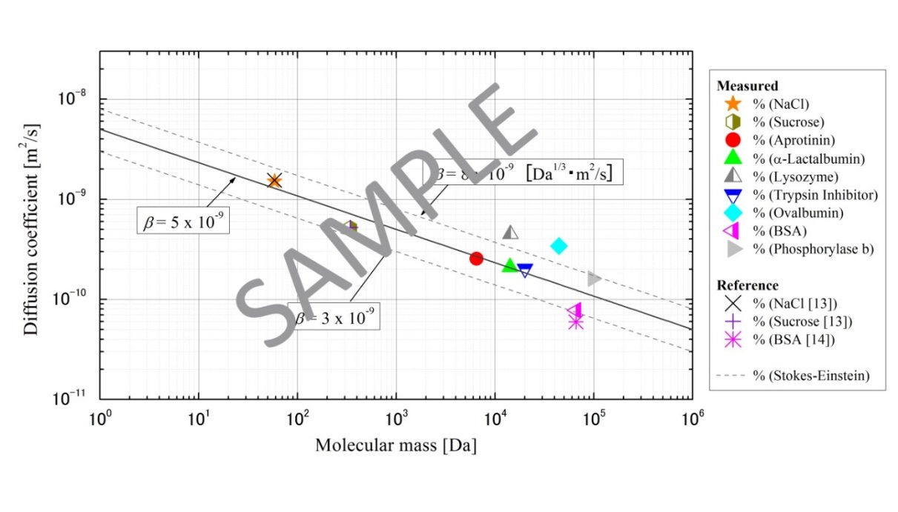
Fig. 1 One-line figure caption is centered under the figure. Make a space above the figure caption. (10 pt)

Table 1 The table caption is above the table. Captions that are two or more lines are flushed left, one line space above and below the caption. (10 pt)

Case | Diameter, (mm) | (Hz) | We | St
1 | 0.5 | 731 | 117 | 0.15
2 | 0.5 | 1799 | 620 | 0.16
3 | 1.3 | 198 | 124 | 0.17

4. CONCLUSIONS

ACKNOWLEDGMENTS

Acknowledgments should be placed immediately following CONCLUSIONS, if necessary.

NOMENCLATURE

The editors of the major heat transfer journals have adopted a common list of symbols. The symbol list can be found in Journal of Heat Transfer, 121, 770-773 (1999). All authors should use these symbols for the extended abstract submitted for this conference. The symbols defined in this common list need not be included in the nomenclature list; only symbols unique to the extended abstract should be listed here. A short nomenclature defining unusual or non-standard symbols should be placed immediately above the REFERENCES. SI Units must be used.

Be dimensionless variable ( - )
Ĉ second variable (s²)
Q_{A} third variable (kJ)
w_{x} fourth variable (m²/s)
ϕ(Ω) function
ζ dimensionless variable ( - )
Ω fifth variable ( s⁻¹ )

REFERENCES

Arabic numerals in square brackets [ ] and formatted according to the following samples. Incorrectly formatted reference lists will be returned to the author for correction before acceptance. References should be in Times New Roman, 9 pt, justified copy, first line flush left, remaining lines indented (see, Reference list exemplified below).

[1] Author, A. A., Author, B. B., and Author, C. C., “Title of article,” Title of Journal, 12 (Volume), 231-251 (Pages) (2009). (Year) Journal Paper Having Conventional Page Numbers This note means that this is an example of a journal paper. The same applies to the following lines. Please remove all these red bold-face texts in your manuscript.
[2] Author, A. A., Author, B. B., and Author, C. C., “Title of article” Title of Journal, 34, 123456 (2014). Journal Paper with an Article Number
[3] Author, A. A. and Author, B. B., “Title of article,” Title of Journal. doi: abced/fghij/12345. Journal Paper Published Online with DOI
[4] Author, A. A. and Author, B. B., “Title of article,” Title of Journal, 56. Retrieved month day, year, from http://www.someaddress.com/full/url/, (Date of publication). Other Online Scholarly Journal Article
[5] Nield, D. A. and Bejan, A., Convection in Porous Media, New York: Springer-Verlag, pp. 125–176 (2005). Book
[6] Buyevich, A. and Alexandrov, D.V., Heat Transfer in Dispersions, Connecticut: Begell House, Available at http://www.edata-center.com/ebooks/b7f98f1e271b3e77a.html/ EBooks [accessed May 5, 2005] (2005). E-Book
[7] Yang, W. and Kim J. H., Eds., Rotating Machinery, New York: Begell House (1992). Edited Book
[8] Nishikawa, K. and Ito, T., “Augmentation of Nucleate Boiling Heat Transfer by Prepared Surfaces,” In Mizushina, T. and Yang W. J., Eds., Heat Transfer in Energy Problems, Washington, D.C.: Hemisphere Publishing, pp. 111–1182 (1982). Chapters of Edited Book
[9] Ma, T. M., “Effects of Geometrical Shapes of Reentrant Grooves on Boiling Heat Transfer from Porous Surfaces,” Heat Transfer 1986, Proc. of 8th Int. Heat Trans. Conf., vol. 4, pp. 2013–2018 (1987). Conference Proceedings
[10] Richmond, J., Steady State Thermal Conductivity, Ph.D. Thesis, University of Connecticut (2004). Dissertation
[11] Author, A. A. and Author, B. B., Title of document. Retrieved month day, year, from http://Web address, (Date of publication). Webpages: Nonperiodical Web Document
[12] Author, A. A. and Author, B. B. Title of article. In Title of book or larger document (chapter or section number). Retrieved month day, year, from http://www.someaddress.com/full/url/, (Date of publication). Chapter or Section of a Web Document

